

Request for proposals: 2023 Lake Conservation Grant

We request project proposals for funding from the Midwest Glacial Lakes Partnership (MGLP) 2023 Lake Conservation Grant. The MGLP is one of twenty partnerships that span the nation under the umbrella of the National Fish Habitat Partnership (NFHP). The MGLP area of focus is glacial lakes and their watersheds (see figure). Nine Midwestern states, federal agencies including the U.S. Fish and Wildlife Service (USFWS), U.S. Geological Survey, and the U.S. Forest Service, tribal partners, and private natural resource entities including The Nature Conservancy, have been integral partners in the development and operation of the MGLP.

*The MGLP works to protect, rehabilitate, and enhance sustainable fish habitats in glacial lakes of the Midwest (black stippled area) for the use and enjoyment of current and future generations.*

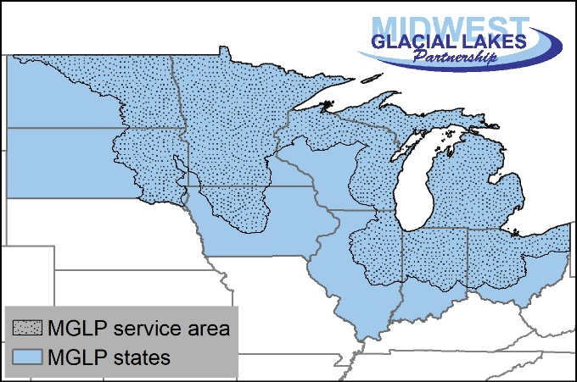

We support conservation projects that work toward meeting the goals and objectives set forth in the MGLP Strategic Plan ([midwestglaciallakes.org/resources](http://midwestglaciallakes.org/resources/)) to benefit glacial lake fish habitats, which include addressing the chemical, physical, and biological components of the habitats that fishes found in glacial lakes use throughout their lives. We have directed funding toward a wide range of aquatic conservation projects that benefit imperiled, endangered, and recreational fish species and their habitats. We typically fund 3-5 projects annually between $30,000 and $100,000, but larger projects will be considered for funding up to a maximum of the approximately $360,000 expected for distribution. Projects have been successfully implemented because contributions and capabilities of many partners have been combined to accomplish project goals that none of the partnering entities could accomplish on their own.

Projects considered for funding **must** align with the goals and objectives of the MGLP and can range in scale from projects that affect one or more sites, lakes, or watersheds. Projects should address the processes that cause fish habitat impairments as opposed to managing or treating the symptoms of those causes. Examples include, but are not limited to:

* projects that implement or demonstrate new approaches
* watershed-level nutrient control projects;
* water quality and erosion control measures;
* native vegetation or wetland rehabilitation;
* natural riparian or in-lake habitat restoration and protection;
* barrier removal for improved native fish passage;
* fish population or watershed assessments needed for project evaluation;
* habitat assessment, prioritization and planning for future habitat projects;
* evaluating current and future habitat conditions;
* projects addressing climate change adaptation or mitigation through fish habitat;
* projects training biologists and managers on inland lake fish habitat management tools and approaches; and
* community outreach and education on the importance of and how to better conserve glacial lake fish habitat.

In addition to conducting independent outreach and/or education, successful applicants will be expected to work with the MGLP to coordinate media and public outreach to raise the profile of MGLP-funded projects.

If you have a lake conservation project aligned with the goals and objectives of the MGLP and need financial assistance, we encourage you to submit a proposal for project funding. If you have any questions, please contact Joe Nohner at [nohnerj@michigan.gov](mailto:nohnerj@michigan.gov) or 517-284-6236 or Gary Whelan, MGLP Steering Chair, at [whelang@michigan.gov](mailto:whelang@michigan.gov). An application for funding is included with this announcement and you can submit your application by emailing it to MGLP Coordinator Joe Nohner at [nohnerj@michigan.gov](mailto:nohnerj@michigan.gov).

Eligibility and administrative information

Eligible Applicants: Eligible applicants include state and federal management agencies, non-governmental organizations (e.g., conservation groups, community associations, watershed councils, cooperatives, civic groups), municipalities, universities, schools, private landowners, and local and tribal governments.

Projects carried out by Indian Tribes may be eligible for additional funding from the National Fish Habitat Partnership and have special considerations relaxing match funding requirements. We are still awaiting administrative interpretation of these considerations; if your project is led by or in collaboration with an Indian Tribe, please contact Joe Nohner to discuss further.

What types of projects may NOT be funded?

Funds may NOT be expended on the following. If any of these activities is integral to a project that addresses the MGLP strategic action plan, funds from other sources can support the activities, but not NFHP funds. However, those other funds may qualify for matching or leverage purposes.

Ineligible costs

1. Pre-award costs associated with preliminary design, surveys, and appraisals.
2. Realty costs (e.g., lease or purchase interests in real property or to make rental or other land use incentive payments to landowners).
3. Operation and maintenance of facilities or structures. This applies to buildings and structures only and not to maintenance or construction of earthen structures.
4. Actions required by existing regulatory programs, except funds may support activities under voluntary agreements that exceed regulatory requirements for conserving habitats (e.g., hydropower licensing in which the licensee enters into a voluntary agreement to restore habitat that exceeds regulatory requirements).
5. Projects that are primarily research studies (fish habitat assessment projects can be funded and are not considered research).
6. Long term monitoring projects (this includes long term monitoring of fish populations)
7. Incentive payments.

Available Funding: The MGLP plans to allocate approximately $360,000 among one or more individual projects for this cycle. However, the exact amount of funding available to the partnership varies annually depending on the final budget allocation with final fund availability determined in the spring.

Match Required: Successful proposals must demonstrate a 1:1 or greater non-federal match, which may include cash, time, materials, or other in-kind services. **Greater match funding among all sources will result in a more competitive project proposal; our goal is to exceed a 3:1 match ratio (potentially including federal sources) across the portfolio of funded projects.** See appendix for more information regarding calculating match. There are no match requirements for projects carried out by Indian Tribes. Match must occur during the project period.

Deadline: Applications are due by **February 18, 2022.** In order to help applicants put forward the best possible projects for consideration by the MGLP Steering Committee, MGLP has a set of criteria by which projects are evaluated for funding and applicants should address these criteria in their project applications. Please review the attached materials for project selection criteria and application instructions. MGLP Coordinator Joe Nohner can assist with the development and implementation of projects.

Decision process and timeline for funding: The Midwest Glacial Lakes Partnership will recommend projects to the NFHP Board by March 31, 2022. The NFHP Board will consider MGLP recommendations and make a recommendation to the Department of Interior by July 1, 2022, for approval and funding. The MGLP will communicate all funding decisions to applicants as soon as possible, with decisions anticipated during Fall 2022 – Winter 2023.

Project Duration: MGLP-funded projects are likely to be contracted and available in early 2023 with a likely completion date of September 30, 2025. In some cases, the MGLP will consider funding phases or components of larger, long-term projects, as long as funds can be expended, objectives met, and benefits realized by the likely completion date. Multiple-year requests beyond the above time limitations will not be considered at this time.

Grant administration: Project agreements will be administered by the USFWS. Successful applicants to the MGLP Lake Conservation Grant will then work with USFWS to create and administer grant agreements; additional information about this process for applicants receiving MGLP Lake Conservation Grants can be found in this [USFWS Application & Award Requirements](http://midwestglaciallakes.org/wp-content/uploads/2021/11/2021-10-27_NFHP-Application-and-Award-Requirements.pdf) document.

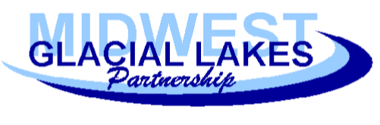Midwest Glacial Lakes

Fish Habitat Partnership

2022 Lake Conservation Grant

Application Instructions

**Consultation**

▪ Prior to submission, you must discuss your project with the MGLP Coordinator (Joe Nohner; [nohnerj@michigan.gov](mailto:nohnerj@michigan.gov); 517-284-6236) for preliminary feedback on project fit for the grant and areas for improvement.

**Submission Instructions**

▪ Complete a cover letter than includes a brief narrative describing the overarching project goals and anticipated outcomes; why MGLP funds are needed; how MGLP funds will be spent; and how this project addresses MGLP and NFHP National Conservation Priorities (See Appendix).

▪ Complete this grant application form as a Word document, a completed budget template in Excel, and provide any supporting information. Other letters of support, designs, watershed or lake plans, planning documents, permits, articles, scientific studies, etc. are optional but encouraged.

▪ Acquire a required letter of support from the State Fish and Wildlife Agency.

▪ All file names should include the project name.

▪ Submit the above items electronically as an email attachment to the MGLP Coordinator (Joe Nohner [nohnerj@michigan.gov](mailto:nohnerj@michigan.gov))

**Please note, the Midwest Glacial Lakes Partnership will not consider:**

1. Late requests.

2. Requests for projects or programs already completed.

3. Refunding projects, programs or items purchased before the project is approved or awarded.

4. Participating in or funding of any political campaign on behalf of any issues, organizations or candidates.

**Deadline**

Applications are due by **February 18, 2022.**

If you have any questions, please contact Joe Nohner at [nohnerj@michigan.gov](mailto:nohnerj@michigan.gov) or 517-284-6236 or Gary Whelan, MGLP Steering Chair, at [whelang@michigan.gov](mailto:whelang@michigan.gov).

Midwest Glacial Lakes

Fish Habitat Partnership

Project Selection Guidelines, Evaluation Criteria and Process

The MGLP Steering Committee will review and evaluate proposals based on the criteria listed below. A list of the projects that are recommended for funding will be submitted to the National Fish Habitat Board and ultimately the U.S. Department of Interior for final approval. Grant agreements will be completed with recipients by September 30, 2023, although they may be completed earlier in federal fiscal year 2023. Project applicants should address these requirements, guidelines, and criteria below in their project applications.

Requirements

1. Project must be consistent with specific MGLP goals and objectives as outlined in the MGLP Strategic Plan (available for download at <http://midwestglaciallakes.org>).

2. Project must benefit at least one native fish species in its historic range on a lake within the MGLP. The MGLP border has been revised; you can confirm eligibility through discussion with Joe Nohner.

3. Project proposals must be supported in writing by state and/or federal fish and wildlife management agencies, or tribal governments, within project-area jurisdictions. Project application must include a signature and contact information for a ‘sponsoring professional’ from a relevant management agency.

4. If project is located on private land, a support letter from the landowner will be required.

5. Projects must include an education and outreach component that includes the local or regional community.

6. Projects must include monitoring and evaluation measures.

7. Successful applicants must agree to submit a short completion report to Joe Nohner (nohnerj@michigan.gov) within one month of project completion that describes project outputs, outcomes, and lessons learned in accordance with the MGLP completion report template.

General Criteria and Considerations

Strong applications should address the criteria and considerations below satisfactorily.

* Is the project likely to succeed? In other words, are the methods, applicant expertise, committed funding, and other factors sufficient to ensure likely success?
* Does the project address more than one of the goals or objectives listed above and in the MGLP Strategic Plan, or a priority need or limiting factor in a species conservation, management or recovery plan? If so, please reference and explain.
* Does the project protect or restore a natural process, and/or address a root cause of decline or habitat degradation? Is the project self-sustaining over time (preferred), or will it require periodic/regular maintenance? Please describe.
* Does the project address a need identified in a lake management plan or the MGLP Conservation Guidelines for the lake? MGLP Conservation Guidelines for most lakes can be found on the [MGLP Conservation Planner](http://midwestglaciallakes.org/resources/conservationplanner/).
* Does the application establish that the project is technically sound and supported by the best available science or knowledge in the field, and are the project objectives realistic, measurable, and achievable?
* Does the project convey a large conservation benefit to a MGLP priority species? Priority species can be found in the [MGLP Strategic Plan](http://midwestglaciallakes.org/wp-content/uploads/2020/06/MGLP-Strategic-Plan-2020-2025.pdf).
* Does the project have a high probability of being completed within the proposed project timeline?
* For habitat and restoration projects, are there adequate assurances that the project will be monitored and the benefits maintained over the long term (we prefer projects that will sustain themselves after completion)? If necessary, are there provisions for operation and maintenance?
* After project completion, is the lake ecosystem expected to be resilient (preferred) or vulnerable to climate change in the future? Vulnerability will be determined based in part on the potential loss of habitat suitable for cool or coldwater species under climate change as modeled by the MGLP in its [Conservation [Planner](http://midwestglaciallakes.org/resources/conservationplanner/)](http://midwestglaciallakes.org/resources/conservationplanner/).
* Will the project increase or protect a lake’s resilience to climate change? Examples could include restoring fish passage to mitigate fish kills or minimizing eutrophication that exacerbates the loss of cool, oxygenated habitats for fishes.
* Who are the various partners that will participate in the administration and implementation of the project? Does the partner list include stakeholder organizations with diverse experiences, roles, and relationships to the project?
* Does the project include an outreach and/or education component? In addition to conducting independent outreach and/or education, successful applicants will be expected to work with the MGLP to coordinate media and public outreach to raise the profile of MGLP-funded projects.
* Project alignment/compatibility with other conservation plans (e.g., State Wildlife Plans;

Biological Opinions; Land Management Plans).

* Does the proposal identify specific habitat measures of success and performance targets that are observable and amenable to pre- and post-project monitoring and include social, economic and biological benefits such as enhanced recreational, commercial and subsistence fishing opportunities, increased public visitation, or innovative project designs that address specific fish conservation challenges?
* Is the budget well-defined and linked to clear deliverables and outcomes?
* Are external funds leveraged in support of the proposed project?

 Midwest Glacial Lakes

Fish Habitat Partnership

2023 Lake Conservation Grant Application

**Contact Information:**

**Project Officer:** **Project Co-Officer:**

|  |  |  |  |
| --- | --- | --- | --- |
| Name: |  | Name: |  |
| Affiliation |  | Affiliation |  |
| Mailing Address: |  | Mailing Address: |  |
| Email Address: |  | Email Address: |  |
| Phone Number: |  | Phone Number: |  |

**Project title: (max chars: 100)**

|  |
| --- |
|  |

**Specific waterbody affected**

|  |
| --- |
|  |

**Watershed Hydrologic Unit Code** (HUC8; available for most lakes through the [MGLP Conservation Planner](http://midwestglaciallakes.org/resources/conservationplanner/))

|  |
| --- |
|  |

**Geographic Location (For Latitude and Longitude, use NAD-1983)**

|  |  |  |  |  |  |  |
| --- | --- | --- | --- | --- | --- | --- |
| Project Name | County | State | Congressional District(s)* | Lake(s) MGLP ID** | Latitude (decimal degrees) | Longitude  (decimal degrees) |
| *Example: Torch Lake restoration* | *Antrim* | *MI* | *MI-1* | *MIbrdch17478* | *44.95579* | *-85.30113* |

* You can find your Congressional District(s) [here](https://www.govtrack.us/congress/members/map).

**MGLP IDs for most lakes areavailable at the [MGLP Conservation Planner](http://midwestglaciallakes.org/resources/conservationplanner/). For eligible lakes without an MGLP ID, this field can be skipped.

**Ceded Territory**

Does this project affect Ceded Territory? If the project affects ceded territory, but does not include tribal partners, please explain why not. Ceded Territory maps can be found in the [MGLP Conservation Planner](http://ifrshiny.seas.umich.edu/mglp/) by clicking the “Background map” button and turning on the “Show ceded territories” toggle.

**PROJECT SUMMARY** (200-word limit)

**State, Tribal, or Federal Agencies responsible for resource management in area where project will be located: choose all that apply**

|  |  |  |  |
| --- | --- | --- | --- |
|  | 1854 Treaty Authority |  | Ohio Department of Natural Resources |
|  | Illinois Department of Natural Resources |  | South Dakota Game, Fish and Parks |
|  | Indiana Department of Natural Resources |  | Wisconsin Department of Natural Resources |
|  | Inter-Tribal Council of Michigan |  | U.S. Fish and Wildlife Service |
|  | Iowa Department of Natural Resources |  | U.S. Forest Service |
|  | Great Lakes Indian Fish and Wildlife Commission |  | U.S. Park Service |
|  | Michigan Department of Natural Resources |  | U.S. Bureau of Reclamation |
|  | Minnesota Department of Natural Resources |  | U.S. Bureau of Land Management |
|  | North Dakota Game & Fish Department |  | Other tribal management:_____ |

**Contact information for the Sponsoring Biologist at State, Tribal, or Federal Agency**

|  |  |
| --- | --- |
| **Name:** |  |
| **Telephone:** |  |
| **Email:** |  |

**Funding Request:**

|  |  |
| --- | --- |
| **MGLP Funding Request:** |  |
| **Total Partner Match: In-kind**  **Funding** |  |
|  |
| **Project Total (including match): $** |  |

**If the project is scalable, please state the minimum amount of funding that you would be able to accept and still complete a substantially similar project.**

**Budget:** Provide project budget details for personnel, supplies, equipment (including rental), permitting, and other costs [using the budget template available on the MGLP Aquatic Conservation Grant website](http://midwestglaciallakes.org/wp-content/uploads/2018/08/MGLP-Grant-FY19-Detailed-Budget-Template.xlsx). Please provide any justifications or explanations in a narrative below.

**Contributing Partners:** Please list specific partner names and their proposed contributions, including in-kind service cash value (*example: 100 volunteer hours of shoreland restoration in-kind value of $1800*).

|  |  |  |  |  |
| --- | --- | --- | --- | --- |
| **Partner** | **Federal or federally tied (Yes/No)** | **Cash** | **In-kind** | **Total** |
|  |  |  |  |  |
|  |  |  |  |  |
|  |  |  |  |  |
|  |  |  |  |  |
|  |  |  |  |  |
|  |  |  |  |  |
| Total |  |  |  |  |

*Note: Please try to account for all proposed partners and their cash and in-kind contributions. Remember, in-kind contributions can add a significant amount to partner match and make your project more competitive, so please consider all contributions made to the project effort and convert those into in-kind matching dollars.*

**Public fishing access:**

**Already available at project site**

**Access to fishing created or improved (please describe)**

**No fishing access after project completion**

**Regional project (please summarize fishing access for affected lakes)**

**Amount and Type of Habitat Affected:** (may have multiple types)

|  |  |  |  |  |  |
| --- | --- | --- | --- | --- | --- |
| Riverine in miles | Lake in acres | Wetland in acres | Riparian in miles | Riparian in acres | Upland in acres |
|  |  |  |  |  |  |

**Species Targeted for Conservation** Please note any MGLP Priority Species (listed in the [Strategic Plan](http://midwestglaciallakes.org/wp-content/uploads/2020/06/MGLP-Strategic-Plan-2020-2025.pdf)) or Species of Greatest Conservation Need.

**Other Species Benefitting from Conservation** Please note any MGLP Priority Species (listed in the [Strategic Plan](http://midwestglaciallakes.org/wp-content/uploads/2020/06/MGLP-Strategic-Plan-2020-2025.pdf)) or Species of Greatest Conservation Need.

**Conservation Actions Taken:** choose all that apply**.**

Reconnect aquatic habitat

Reduce nutrient loading

Reduce sediment loading

Rehabilitate or restore sediment transport

Remove fish barrier(s)

Protect healthy habitat

Rehabilitate or restore natural variability in river and stream flows

Rehabilitate or restore natural variability in water surface elevations in natural lakes

Control/eradicate invasive species

Protect, rehabilitate or improve physical fish habitat (woody habitat, lunker structures, etc.)

Outreach and education to _______________ (please estimate total audience size)

Conservation planning assessment

Other, explain________________________________________________

**Explain how the project aligns with the relevant lake management plan(s) or the management guidelines provided by the** [**MGLP Conservation Planner**](http://midwestglaciallakes.org/resources/conservationplanner/) **(if no lake management plans exist)** (200-word limit)

**State the problem and the specific cause of the problem to be addressed by the project.** (300-word limit)

**State the proposed benefits of the project:** (1000-word limit). Identify actions to be taken, anticipated ecological response, and benefits to the local economy.

**State the objective(s) of the project with reference to the problem.** Please state in [SMART format](http://www.goal-setting-guide.com/goal-setting-tutorials/smart-goal-setting) (Specific, Measurable, Attainable, Realistic, Time bound)(300-word limit). For example, “By September 30, 2025, we will construct rock-arch rapids that allow for fish passage below the Clear Lake water level control structure.”

**State the methods used to accomplish the objective(s).** Be specific**.** (1000-word limit)

**How long are the benefits of the project expected to last and how will those benefits be sustained over time?** (100-word limit)

**Will the project address the effects of climate change on inland lakes and if so, how?** (Note that the [MGLP Conservation Planner](http://midwestglaciallakes.org/resources/conservationplanner/) includes climate change vulnerability and species suitability information; 100-word limit)

**Project Completion**

Please choose an estimated time period in which on-the-ground work is proposed to be completed from the time of receiving funds (usually summer).

6 months

12 months

18 months

Other (estimated) __________________________

What is your approximate start date for this project? ______________________________

**Monitoring and Evaluation**

A monitoring and evaluation component is required for every project. Describe the plan for monitoring completion of objectives and evaluation of attempts to achieve these objectives. (200-word limit)

**Education and Outreach**

An education and outreach component is required for every project. Describe the outreach or education components for this project including the local or regional community. Examples could include a combination of posting signage at restored or protected areas, conducting workshops, webinars, newspaper articles, in-person presentations, mailings, door-to-door outreach campaigns, social media messages, and/or other options. (200-word limit)

**Project team**. Demonstrate the applicant’s ability to implement a project of this nature. Outline how typical project roles such as manager, engineer, partners, and public involvement will be selected or handled during this project. Include examples the project team may have with this type of project. (250-word limit)

**Necessary authorizations.** Does this project have any special regulatory considerations, and if so, how will you address them? This may include mussels, threatened and endangered species, contaminated sediment, sea lamprey management, and/or other regulatory considerations. (250-word limit)

**PHOTOGRAPH(S) OF PROJECT AREA**

Please include two to five photographs of proposed project area in this application document or attached to the submission. Before and after photographs are required after project completion. Each photo should be accompanied by:

1. • A short, descriptive caption
2. • Credit: photographer’s name/organization

**MAP OF PROJECT AREA**

Please upload a map of the project area.

EXAMPLE MAP

Sample Project Location

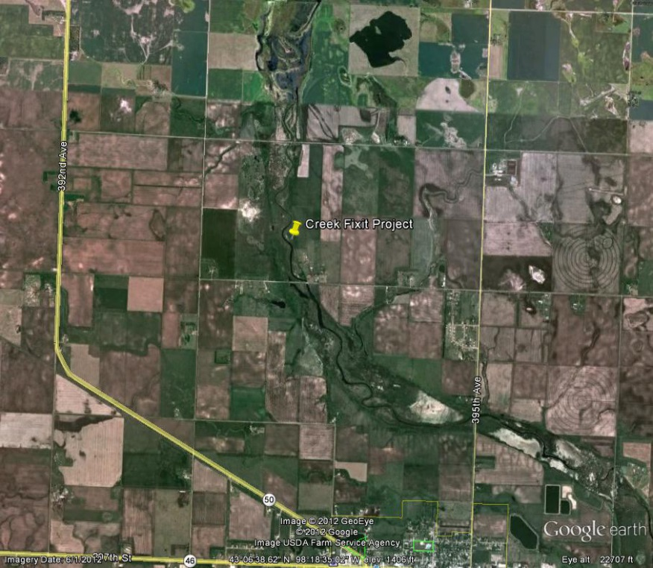

**Optional: State any additional information describing the importance of this project.**

Appendix. National Fish Habitat Partnership (NFHP) National Conservation Priorities

FY2023 NFHP National Conservation Priorities

1) Protect intact healthy waters

2) Restore hydrologic conditions for fish

3) Reconnect fragmented fish habitats

4) Restore water quality

5) Coordination and operational support for FHPs to make on-the-ground progress within program appropriations