

August 6, 2018

Midwest Glacial Lakes Fish Habitat Partnership

Request for 2019 Aquatic Conservation Projects

The Midwest Glacial Lakes Partnership (MGLP) is announcing its request for fish habitat conservation project proposals. The MGLP is one of twenty partnerships that span the nation under the umbrella of the National Fish Habitat Partnership (NFHP). The MGLP area of focus is glacial lakes and their watersheds (see figure). Eight Midwestern states, federal agencies including the U.S. Fish and Wildlife Service, U.S. Geological Survey, and the U.S. Forest Service, and private natural resource entities including The Nature Conservancy, have been integral partners in the development and operation of the MGLP.

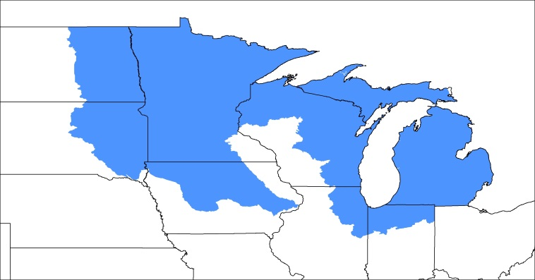This will be our tenth year of supporting conservation projects and working toward meeting the goals and objectives set forth in the MGLP Strategic Plan (midwestglaciallakes.org), and we have directed funding toward a wide range of aquatic conservation projects that benefit imperiled, endangered, and recreational aquatic species and their habitat. While direct partnership funding to date has been limited to only that provided by the U.S. Fish & Wildlife Service (USFWS), we have been able to use both NFHP funds and USFWS Fish Passage funds on high priority projects to increase the overall contribution. Most projects have received between $10,000 and $75,000 from the MGLP, but larger projects are possible for funding from the approximately $300,000 expected for distribution. Projects have been successfully implemented because contributions and capabilities of many partners have been combined to accomplish project goals that none of the partnering entities could accomplish on their own.

*The Midwest Glacial Lakes Partnership works to protect, rehabilitate, and enhance sustainable fish habitats in glacial lakes of the Midwest (blue shaded area) for the use and enjoyment of current and future generations.*

If you have an aquatic conservation project aligned with the goals and objectives of the MGLP and need financial assistance, we encourage you to submit a proposal for project funding. An application for funding is included with this announcement and you can submit your application by emailing it to MGLP Coordinator Joe Nohner at [nohnerj@michigan.gov](mailto:nohnerj@michigan.gov). If you have any questions, please contact Joe Nohner at 517-284-6236 or Todd Tisler, MGLP Steering Committee Chair, at [ttisler@fs.fed.us](mailto:ttisler@fs.fed.us) or 218-335-8629.

Midwest Glacial Lakes

Fish Habitat Partnership

Eligibility and Requirements

Eligible Applicants: Eligible applicants include state and federal management agencies, non-governmental organizations (e.g. conservation groups, community associations, watershed councils, cooperatives, civic groups), municipalities, universities, schools, private landowners, and local and tribal governments.

Eligible Projects: Projects considered for funding must align with the goals and objectives of the MGLP. Examples include: watershed-level projects; water quality and erosion control measures; riparian or in-lake habitat restoration and protection; barrier removal or construction; population or watershed assessments needed for project evaluation; prioritization and planning for future habitat projects; evaluating habitat conditions or lake water levels; and community outreach and education on the importance of and how to better protect fish habitat.

What types of projects may NOT be funded?

Funding for projects comes from the FWS and follows Policy 717 FW1 [www.fws.gov/policy/717fw1.html](http://www.fws.gov/policy/717fw1.html). Funds may NOT be expended on the following listed activities under Section 1.8 of Policy 717 FW 1. If any of these activities is integral to a project that addresses the MGLP strategic action plan, funds from other sources can support the activities, but not NFHP funds. However, those other funds may qualify for matching or leverage purposes.

Ineligible costs

1. Pre-award costs associated with preliminary design, surveys, and appraisals.
2. Realty costs (e.g., lease or purchase interests in real property or to make rental or other land use incentive payments to landowners).
3. Operation and maintenance of facilities or structures. This applies to buildings and structures only and not to maintenance or construction of earthen structures.
4. Actions required by existing regulatory programs, except that funds may support activities under voluntary agreements that exceed regulatory requirements for conserving habitats (e.g., hydropower licensing in which the licensee enters into a voluntary agreement to restore habitat that exceeds regulatory requirements).
5. Projects that are primarily research studies (fish habitat assessment projects can be funded and are not considered research).
6. Long term monitoring projects (this includes long term monitoring of fish populations)
7. Incentive payments.

Project Duration: MGLP funds projects must be completed within 18-24 months of receipt of funding; funds are anticipated to be available to successful applicants in September 2019. In some cases the MGLP will consider funding phases or components of larger, long-term projects, as long as funds can be expended, objectives met, and benefits realized within the 24-month period. Multiple-year requests beyond the above time limitations will not be considered at this time.

Available Funding: The MGLP plans to allocate about $300,000 among one or more individual projects for federal fiscal year 2019. However, the exact amount of funding available to the partnership varies annually depending on the final USFWS budget allocation with final fund availability determined in the spring.

Match Required: Successful proposals should demonstrate a 1:1 match or greater, which may include cash, time, materials, or other in-kind services. **Greater match funding will result in a more competitive project proposal; our goal is to exceed a 3:1 match ratio across the portfolio of funded projects.**

Deadline: The deadline to submit a MGLP project under the 2019 NFHP funding cycle is **October 15, 2018.** In order to help applicants put forward the best possible projects for consideration by the MGLP Steering Committee, MGLP has a set of criteria by which projects are evaluated for funding and applicants should address these criteria in their project applications. Please review the attached materials for project selection criteria and application instructions. All proposed projects will be entered into the Fish and Wildlife Service Fisheries Information System by Fish and Wildlife Staff. MGLP Coordinator Joe Nohner and staff from each of the Fish and Wildlife Conservation Offices within the MGLP geography can assist with the development and implementation of projects.

Application Package:

The application package should contain the following four items:

1. Cover Letter – The cover letter must include: a brief narrative describing the overarching project goals and anticipated outcomes; why MGLP funds are needed; how MGLP funds will be spent; and how this project addresses MGLP and NFHP funding priorities. NFHP priorities can be found in the [2nd Edition of its National Fish Habitat Action Plan](http://www.fishhabitat.org/files/uploads/National_Fish_Habitat_Action_Plan_2012.pdf).
2. Completed Project Application – The project application form begins on page 7 below.
3. Detailed Project Budget – Detailed information on the project budget must be included using the template available on the MGLP Aquatic Conservation Grant website.
4. Attachments – A letter of support from the State Fish and Wildlife Agency is required. Other letters of support, designs, planning documents, permits, articles, scientific studies, etc. are optional but encouraged.

Midwest Glacial Lakes

Fish Habitat Partnership

Project Application Instructions

**Submission Instructions**

▪ Please combine all documents and attachments into a single pdf file. Number each page.

▪ File names should include the submission date followed by the project name (Example “071512 Prairie Lake Project”)

▪ Submit electronically as an email attachment to Joe Nohner at nohnerj@michigan.gov.

▪ Please note, proposals should not exceed 15 pages, not including attachments such as photos, maps, letters of support, etc.

**Please note, the Midwest Glacial Lakes Partnership will not consider:**

1. Late requests.

2. Requests for projects or programs already completed.

3. Refunding projects, programs or items purchased before the project is approved or awarded.

4. Participating in or funding of any political campaign on behalf of any issues, organizations or candidates.

**Deadline**

Applications are due by 5:00 pm Central Standard Time **October 15, 2018.**

The MGLP Steering Committee will review and rank projects during October 2018. Final selection of projects for FY2019 funds will occur once the MGLP’s 2019 funding allocation is determined in May 2019. Selected applicants will be notified of their selection and informed of the allocation for their projects at that point in time. Selected applications will be reviewed by the National Fish Habitat Board and the US Fish and Wildlife Service for final funding approval in Spring 2019. If you have any questions, please contact Joe Nohner at [nohnerj@michigan.gov](mailto:nohnerj@michigan.gov) or 517-284-6236 or Todd Tisler, MGLP Steering Chair, at [ttisler@fs.fed.us](mailto:ttisler@fs.fed.us) or 218-335-8629.

Midwest Glacial Lakes

Fish Habitat Partnership

Project Selection Guidelines, Evaluation Criteria and Process

The MGLP Steering Committee will review and evaluate proposals based on the criteria listed below and consider project rankings from species conservation teams and U.S. Fish and Wildlife Service regional managers. A list of the projects that are selected for funding will be submitted to the U.S. Fish and Wildlife Service for final approval. Funds typically become available during the summer or fall following grant approval. To help applicants put forward the best possible proposals, MGLP has provided below a set of criteria and considerations by which projects are evaluated for funding. Project applicants must address these requirements, guidelines, and criteria in their project applications.

Requirements

1. Project must be consistent with specific MGLP goals and objectives as outlined in the MGLP Strategic Plan (available for download at <http://midwestglaciallakes.org>).

2. Project must benefit at least one of the MGLP native species in its historic range.

3. Project proposals must be supported by state and/or federal fish and wildlife management agencies, or tribal governments, within project-area jurisdictions. Project application must include a signature and contact information for a ‘sponsoring professional’ from a relevant management agency.

4. If project is located on private land, a support letter from the landowner will be required.

5. Successful applicants must agree to produce a short completion report within one month of project completion that describes project outputs, outcomes, and lessons learned in accordance with the MGLP completion report template.

General Criteria and Considerations

* Is the project proposal well-written and complete; does it provide sufficient information on methodology and monitoring to evaluate the project?
* Does the project address more than one of the goals or objectives listed above and in the MGLP Strategic Plan, or a priority need or limiting factor in a species conservation, management or recovery plan? If so, please reference and explain.
* Does the project protect or restore a natural process, and/or address a root cause of decline or habitat degradation? Is the project self-sustaining over time, or will it require periodic/regular maintenance? Please describe.
* Does the application establish that the project is technically sound and supported by the best available science, and are the project objectives realistic, measureable, and achievable?
* Does the project convey a large conservation benefit to a MGLP priority species? If so, how? (Examples: project benefits a broad geographic area; project benefits a small geographic area with extremely high value). Does the project benefit multiple MGLP or non-MGLP species?
* Is the project part of a larger restoration effort? If so, describe the overall plan.
* Does the project have a high probability of being completed within the proposed project timeline?
* Is a high match ratio available? What % of total project funding is needed from MGLP funding sources? Is the match clearly identified and secured?
* Is the project budget clearly described and reasonable? Is the benefit high relative to cost?
* Are project outcomes quantifiable; is there a clear explanation of how success will be measured and reported (e.g. stream miles, acres of habitat protected or restored, fish population trends)?
* Are there adequate assurances that the project will be monitored and the benefits maintained over the long term? Are there provisions for operation and maintenance?
* Is the lake ecosystem expected to be resilient to climate change in the future? Resilience will be determined based on the potential loss of habitat suitable for cool or coldwater species under climate change as modeled by the MGLP. While this assessment has not yet been publically released, applicants can determine climate change resilience information for their lake(s) by contacting Joe Nohner ([nohnerj@michigan.gov](mailto:nohnerj@michigan.gov)).
* Will the project increase or protect a lake’s resilience to climate change? Examples could include restoring fish passage to mitigate fish kills or minimizing eutrophication that exacerbates the loss of cool, oxygenated habitats for fishes.

Administrative Considerations

* Have required state and federal permits been acquired (i.e. NEPA, 404, SHPO)? Projects with completed environmental compliance will score higher in the ranking criteria.
* Who are the various partners that will participate in the administration and implementation of the project? Is the partner list diverse? Does the partner list include other NFHP-recognized Fish Habitat Partnerships?
* Does the application provide adequate information to assess whether the applicant or implementing partners have the experience and capacity to successfully achieve the goals and objectives as described in the proposal?

Does the project include an outreach and/or education component? (Applicants are encouraged to work with the MGLP to coordinate media and public outreach to raise the profile of MGLP-funded projects).

* Are the responsible parties for reporting requirements and the successful completion of this proposal clearly identified? Who is a point of contact should the Committee have questions regarding this project?

 Midwest Glacial Lakes

Fish Habitat Partnership

Habitat Conservation Project Application

**What type of action would you like the MGLP to consider?**

Conservation Project Funding

Science and Planning Support

Project Endorsement (for projects that address any of the goals and objectives of the MGLP but do not need additional funding)

**Contact Information:**

**Project Officer:** **Project Co-Officer:**

|  |  |  |  |
| --- | --- | --- | --- |
| Name: |  | Name: |  |
| Affiliation |  | Affiliation |  |
| Mailing Address: |  | Mailing Address: |  |
|  |  |  |  |
| Email Address: |  | Email Address: |  |
| Phone Number: |  | Phone Number: |  |

**Title of the project: (max chars: 100)**

|  |
| --- |
|  |

**Specific waterbody affected:**

|  |
| --- |
|  |

**Watershed Hydrologic Unit Code (HUC) to at least the 8 digit level:**

|  |
| --- |
|  |

**Location: (For Latitude and Longitude, use NAD-1983)**

|  |  |  |  |  |  |
| --- | --- | --- | --- | --- | --- |
| Project Name | County | State | Congressional District(s) | Latitude | Longitude |
| *Example: Fish Creek Restoration* | *Mycounty* | *NE* | *NE-03* | *43.8786* | *-103.4589* |

**PROJECT SUMMARY**

**State the proposed accomplishment summary:** (max words: 1000). Identify actions to be taken, anticipated ecological response, and benefits to the local economy.

**State, Tribal, or Federal Agency Responsible for Resource Management in area where project will be located: choose all that apply**

* Illinois Department of Natural Resources
* Indiana Department of Natural Resources ☐
  + - * Iowa Department of Natural Resources ☐
* Michigan Department of Natural Resources
* Minnesota Department of Natural Resources ☐
* North Dakota Game & Fish Department
* South Dakota Game**,** Fish and Parks
* Wisconsin Department of Natural Resources ☐
* U.S. Fish and Wildlife Service
* U.S. Forest Service
* U.S. Park Service
* U.S. Bureau of Reclamation
* U.S. Bureau of Land Management
* Tribal (name(s)___________________________)

**Contact information for the Sponsoring Biologist at State, Tribal, or Federal Agency**

|  |  |
| --- | --- |
| **Name:** |  |
| **Telephone:** |  |
| **Email:** |  |

**Estimated total cost of the project:** (this could include any efforts made toward an overall project’s goal, outside of the portion of the project and/or performance period of this project)

**Budget:** Provide project budget details for personnel, supplies, equipment (including rental), permitting, and other costs using the budget template available on the MGLP Aquatic Conservation Grant website. Please provide any justifications or explanations in a narrative below.

**Funding Request:**

|  |  |
| --- | --- |
| **MGLP Funding Request:** |  |
| **Total Partner Match: In-kind**  **Funding** |  |
|  |
| **Project Total (including match): $** |  |

**Contributing Partners:** Please choose specific partner names and their proposed contributions, including in-kind service cash value (*example: 100 volunteer hours of shoreland restoration In-kind value $1800*). If your partner is not listed please add each additional partner. Add dollar values in the table.

|  |  |  |  |
| --- | --- | --- | --- |
| **Partner** | **Cash** | **In-kind** | **Total** |
|  |  |  |  |
|  |  |  |  |
|  |  |  |  |
|  |  |  |  |
|  |  |  |  |
|  |  |  |  |
| Total |  |  |  |

*Note: Please try to account for all proposed partners and their cash and in-kind contributions. Remember, in-kind contributions can add a significant amount to Partner match and make your project more competitive, so please consider all contributions made to the project effort and convert those into in-kind matching dollars.*

**Public fishing access:**

**Already available at project site**

**Access to fishing created or improved**

**No fishing access (after project completion)**

**Amount and Type of Habitat Affected:** (may have multiple types)

|  |  |  |  |  |  |
| --- | --- | --- | --- | --- | --- |
| Riverine in miles | Lake in acres | Wetland in acres | Riparian in miles | Riparian in acres | Upland in acres |
|  |  |  |  |  |  |

**Species Targeted for Conservation:**

**Other Species Benefitting from Conservation:**

**Conservation Actions Taken:** choose all that apply**.**

Reconnect aquatic habitat

Reduce nutrient loading

Reduce sediment loading

Rehabilitate or restore sediment transport

Remove fish barrier(s)

Protect healthy habitat

Rehabilitate or restore natural variability in river and stream flows

Rehabilitate or restore natural variability in water surface elevations in natural lakes

Control/eradicate invasive species

Protect, rehabilitate or improve physical fish habitat (woody habitat, lunker structures, etc.)

Other, Explain________________________________________________

**State the problem and the specific cause of the problem to be addressed by the project.** (max words: 300)

**State the objective(s) of the project with reference to the problem.** Please state in [SMART format](http://www.goal-setting-guide.com/goal-setting-tutorials/smart-goal-setting) (Specific, Measurable, Attainable, Realistic, Time bound)(max words: 300)

**State the method applied to accomplish the objective(s).** Be specific**.** (max words: 1,000)

**Project Completion**

Please choose an estimated time period in which on-the-ground work is proposed to be completed from the time of receiving funds (usually summer).

6 months

12 months

18 months

Other (estimated) __________________________

What is your approximate start date for this project: ______________________________

**Monitoring and Evaluation**

Describe the plan for monitoring completion of objectives and evaluation of attempts to achieve these objectives.

**PHOTOGRAPH(S) OF PROJECT AREA**

Please include up to two photographs of proposed project area. Before and after photographs are required after project completion. Each photo should be in JPG format and accompanied by:

1. • A short, descriptive caption
2. • Credit: photographer’s name/organization

**MAP OF PROJECT AREA**

Please upload a map of the project area.

EXAMPLE MAP

Sample Project Location

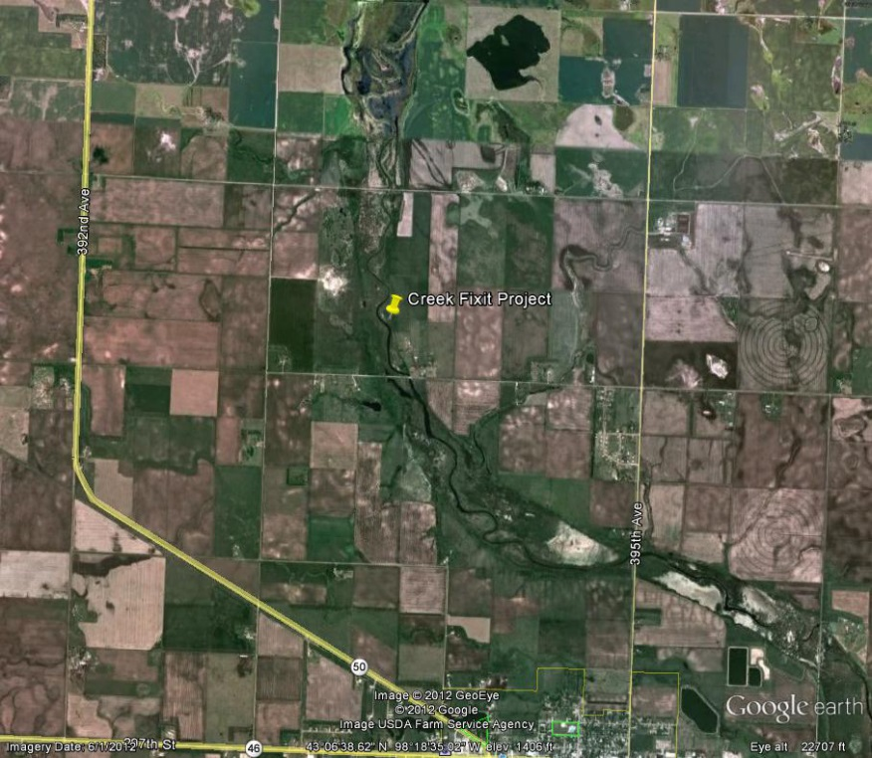

**(Optional) State any additional information describing the importance of this project.**